AVC Project Plan
Team 3
Jawas

Team Name : Jawas
Team Members: Jon Sorenson, Kyle Claudio, Deacon Mcintyre, Eru Ponaho, Sian Fisher

Jon – Project lead, help with hardware and software if needed. Organise team meetings and reports on progress. Ensuring Github is appropriately updated
Kyle – Software development, writing core code and extending functionality, committing any changes to Git, debugging
Deacon – Software development, writing core code and extending functionality, committing changes to Git
Eru – Hardware, in charge of the Github account, building the chassis, connecting sensors and debugging hardware
Sian – Hardware, design of the AVC, building the chassis, connecting sensors, debugging hardware

Our Github Repository which includes our teams goals, code, and designs: https://github.com/Eru-Ponaho/Jawas-avc

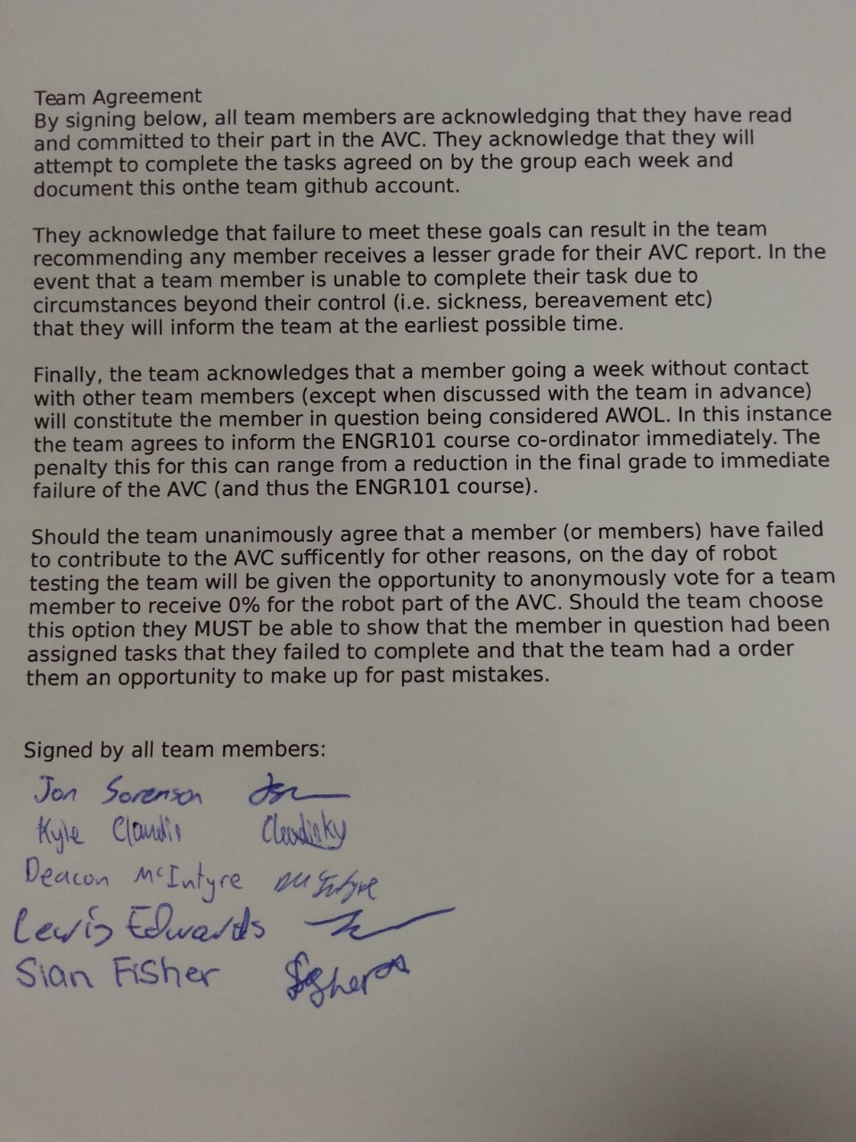

Week | Dates | Team Objectives | Items Due | Conflicting Commitments | Tasks
1 | 18th April | Get robot moving | AVC Plan | PHYS122 | Complete AVC Plan  -Jon arrange meeting times  -Eru set up Github repository  -Eru/Sian inspect and familiarize themselves with hardware  -Kyle/ Deacon familiarize themselves with software
2 | 25th April | Meet and plan for first week back |  |  | All – Write background section  Jon: Arrange team digital meeting, plan for following week  Kyle / Deacon: Suggest order of method development  Eru: Update github with progress from last meeting  Eru / Sian - Finalise chassis design
3 | 2nd May | Quadrant 1 complete |  |  | All - Write Methods section (robot description)  Jon: check team member progress, plan for following week  Kyle / Deacon: Develop robot movement code  Eru: Develop networking code, update github goals  Sian: Characterise motors, chassis build commences
4 | 9th May | Quadrant 2 Complete |  | COMP102 Mid Term | All – Write Results and Discussion Section
5 | 16th May | Quadrant 3 Complete | Progress Report | ENGR121 Mid Term | All - Update sections with new results
6 | 23rd May | Quadrant 4 complete/ double check it works for previous quadrants |  |  | All - Update sections with new results
7 | 30th May |  | Robot Due |  | All - Revise sections based on feedback
8 | 6th June |  |  |  | All - Write conclusion and abstract sections
9 | 13th June |  | Final Report Due | Finals

